# Static vs Dynamic Websites

## Navigating the Distinctions Between Static and Dynamic Websites

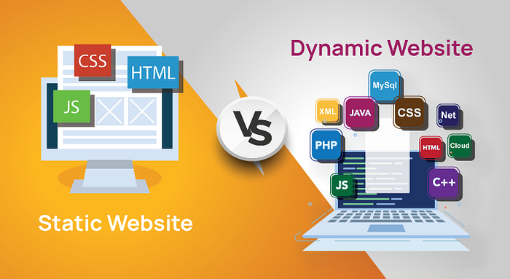

This is a quick read article and part of the major ‘[**Hosting my Static Website in an AWS S3 Bucket**](https://medium.com/@rogernem/hosting-my-static-website-in-an-aws-s3-bucket-d5e1d94417f4#4a10)’ one.

## What is a Website?

A website is usually a collection of web pages with multimedia content (images, videos, and text) and can be accessed using a URL, which is visible in the address bar: <https://www.rogernem.com>.

It can be a landing page, portfolio website, business website, an e-commerce website, an affiliate marketing business website, etc.

## Static vs Dynamic

Before creating a website you need to decide if it will be “static” or “dynamic”, since this will determine how your web pages are stored and delivered to visitors in their browsers.

A **static website** is a collection of web pages that are pre-built during development and **remain unchanged** for every user that accesses them unless modified manually. The **content is fixed**, typically coded in HTML and may include CSS and JavaScript for styling and interactivity. These sites are **suitable for content that doesn’t need frequent updates**.

On the other hand, a **dynamic website** is generated **on-the-fly** in response to user requests. Content is often pulled from a database, allowing for real-time updates and personalized experiences. Dynamic sites commonly use server-side scripting languages like PHP, Python, or Ruby, and may involve a Content Management System (CMS) for easier content management.

Click below to go back and continue reading ‘[**Hosting my Static Website in an AWS S3 Bucket**](https://medium.com/@rogernem/hosting-my-static-website-in-an-aws-s3-bucket-d5e1d94417f4#4a10)’.

## [Hosting my Static Website in an AWS S3 Bucket](https://medium.com/@rogernem/hosting-my-static-website-in-an-aws-s3-bucket-d5e1d94417f4?source=post_page-----4cc7dff82b7e--------------------------------" \t "_blank)

### [And you can do the same too!](https://medium.com/@rogernem/hosting-my-static-website-in-an-aws-s3-bucket-d5e1d94417f4?source=post_page-----4cc7dff82b7e--------------------------------" \t "_blank)

[www.rogernem.com](https://medium.com/@rogernem/hosting-my-static-website-in-an-aws-s3-bucket-d5e1d94417f4?source=post_page-----4cc7dff82b7e--------------------------------" \t "_blank)

**. . .**

**If you enjoyed this article and found it helpful, please don’t forget to leave a heart** ❤**, comment** 💬**, clap** 👏🏻**, and share** ➦ **it to show your support.**

**Also, don’t forget to** [**follow me**](https://medium.com/@rogernem) **for more articles. Thank you!**